Title of One-page Abstract Submission

Author 11, Authors 21, and Author 32

1Department of Electronic Engineering, ABC University, XXX, XXX, Country

Email: abc@abc.com

*Abstract*—The one-page paper abstract should contain the introduction, key methodology or techniques developed or used, key founding, key results and discussion, 2 to 3 key references.

# INTRODUCTION

Scaling of the conventional MOSFET to the nanoscale regime leads to exploring of many novel materials and device structures [1]. Channel strain engineering is being actively pursued for enhancement of carrier mobility and drive current. Uniaxial tensile strain in the Si channel has been reported to significantly enhance the drive current of n-MOSFET [2-4]. Strained-Si has been shown to improve the performance of CMOS structures and 15% improvement is achieved in NMOS and 25% in PMOS **[5].** Strain generated from silicon-carbon (Si1-yCy) source and drain regions was also reported to provide enhancement about 30% in drain current. In this paper, we present a full-band self-consistent Monte Carlo methodology for the analysis of uneven strained Si in MOSFET channel and its impact on the electronic transport properties. The method can be used to study the impact of strain from source and drain regions or substrate.

# methodology

In this proposed method, numerical band structures and density of states (DOS) of strained Si are calculated and tabulated according to the strain distribution. The band structures and DOS of strained Si are then used as the input for the full band self-consistent Monte Carlo device simulator to calculate the performance of the strained Si MOSFET.

Strain distribution in channel is obtained from experimental data. It is then approximated by dividing it into different rectangular areas and each rectangle area is treated as one even strain. In the study, the strain is introduced in the <100> direction and the lattice constant in the other two axis is computed using the elasticity theory. The strain-altered band structures of silicon are calculated using the first principle method density functional theory (DFT) with spin-polarized generalized gradient approximation (SGGA).

A two-dimensional ensemble Monte Carlo device simulator with multiple numerical band structures, self-consistently calculated scattering rates, and quantum corrections is developed based on MOCA [7] to compute the distribution function from the solution of the Boltzmann transport equation (BTE). Particle states and acoustic/optical phonon scattering rates are calculated from the strain induced full-band structures and DOS according to the particle locations in the channel. Impact ionization, ionized impurity scattering and surface roughness scattering are also modeled. The full-band calculations also allow for consideration of strain-induced degeneracy breaking and the associated variations in scattering rates.

# RESULTS AND DISCUSSION

Well-tempered bulk-Si NMOSFET device with 50 nm gate length is used as a basic structure with uneven stained Si in channel in our study (Fig. 1-2). Fig. 2 shows the schematic model of a strain distribution in channel introduced by S/D. The channel is equally divided into 9 parts. Each part is 5.5nm by 10nm. The strain for in plane is 1%, 0.75%, 0.5%, 0.25% from S/D to center of channel.

Fig. 2 shows the calculated band structures and DOS of strained Si (1% tensile in <100> direction) and unstrained Si calculated with DFT SGGA method. The band-spliting and bandgap narrowing resulted from strain can be observed.

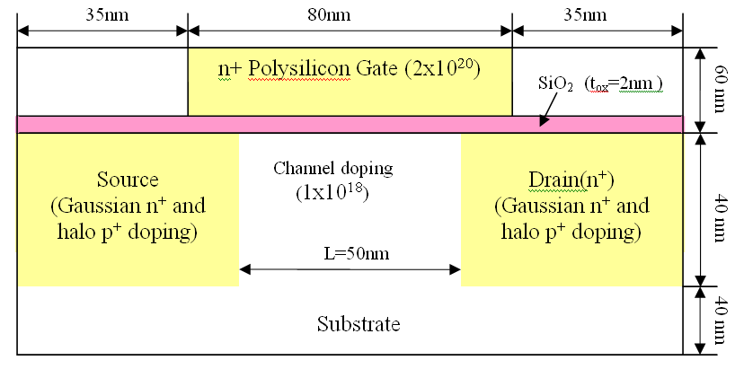

**Fig. 1** Schematic of Well-tempered bulk-Si NMOSFET device



### Fig. 2. Computed Band-diagram of Silicon between Γ and X points.

# REFERENCES

1. Eason, B. Noble, and I.N. Sneddon, “On certain integrals of Lipschitz-Hankel type involving products of Bessel functions,” Phil. Trans. Roy. Soc. London, vol. A247, pp. 529-551, April 1955.
2. J. Clerk Maxwell, A Treatise on Electricity and Magnetism, 3rd ed., vol. 2. Oxford: Clarendon, 1892, pp.68-73.
3. K. Elissa, “Title of paper if known,” unpublished.